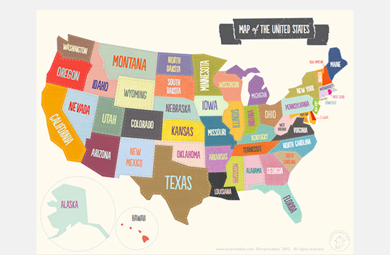
North America

- How many states are there in North America?
_______________________________________________________________________________________________________.
- Who is the President of the USA?
___________________________________________________________________________________________________.
- What is the longest river in the USA?
________________________________________________.
- What languages are spoken?
___________________________________________________________________________________________________.
- Can you draw the flag of the USA here?

