We put 16 frogs in the pot but 3 hopped out again. How many are there left in the pot? A

I had 18 wands but 4 got snapped. How many have I got now? A


I had 12 mice but 5 ran away. How many are left? A


I had 20 pots of potion but 10 got spilt. How many pots are left?
A



I had 35 broomsticks but 10 got snapped. How many are left? A
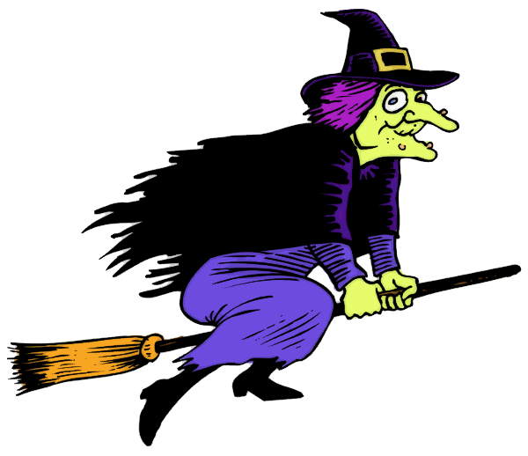

I had 35 black kittens but I sold 7. How many are left?


I put 45 slugs in my bowl for pudding but 10 escaped. How many are left? A


I planted 64 pumpkin seeds but the birds ate 8. How many seeds do I have left? A


