
Kian has 25 football stickers. He shares them between his 5 friends. How many stickers do they get each?
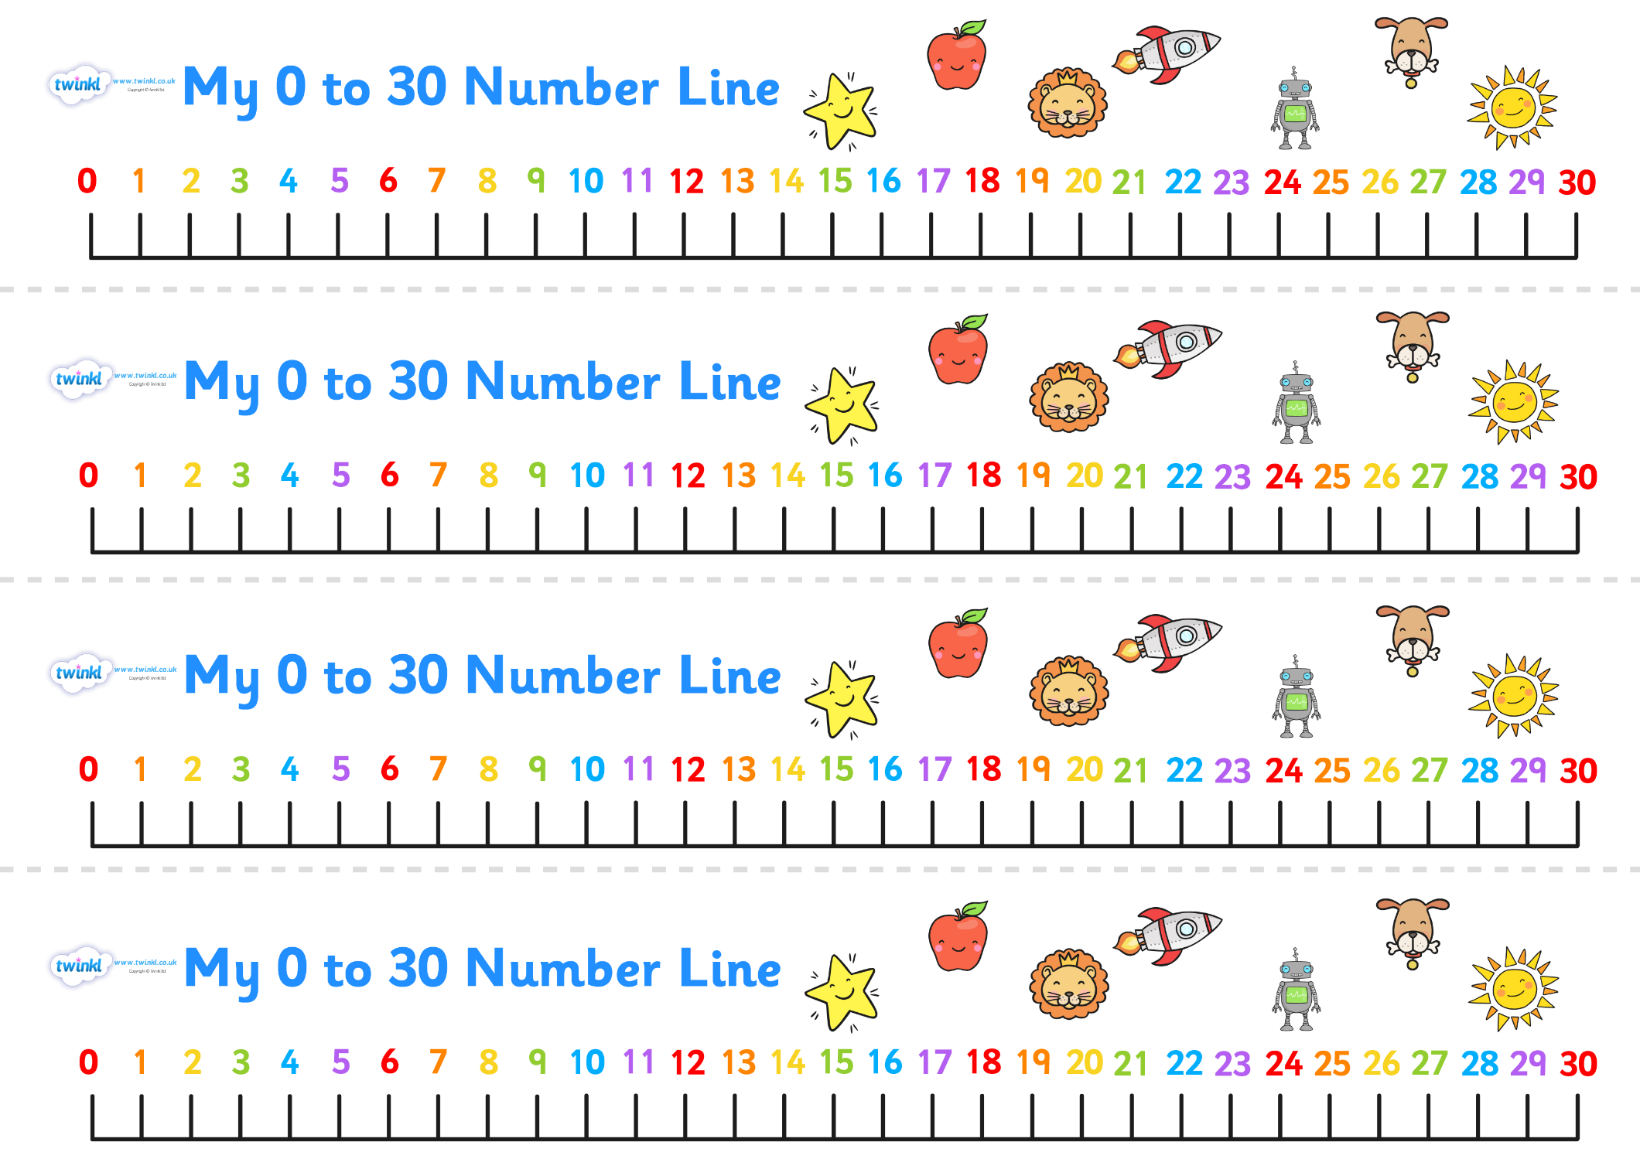

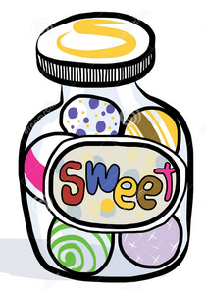
Lottie has 27 sweets. She shares them between 3 children. How many sweets does each child get?

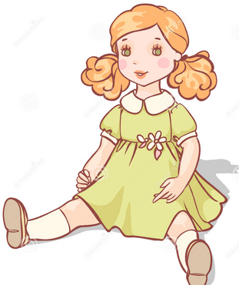
Katie has 12 dolls. She shares them between 3 of her friends. How many dolls do they have each?

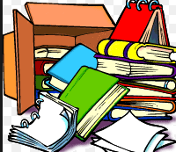
There are 30 books in total and they are packed in boxes of 10. How many boxes are there?


25 flowers are shared between 5 vases. How many flowers go in each vase?


The milkman has 20 bottles of milk, if he delivers 4 bottles to each house, how many houses will he deliver to?

Challenge!!
Using a 0-100 number line, answer these questions with remainders. I have done one for you! (you can write either remainder or just R)
There are 22 children in Emerald class, and 5 tables for the children to work on. How many children will sit on each table?
22 ÷ 5 = 4 remainder 2 The answer is 4 or 5.

Mrs Evans decided to give out 21 Smarties to 4 children in her class. How many Smarties does each child get?

I need to share my 16 cubes between 5 different groups. How many cubes will each group have?

My rabbit eats 10 carrots in 3 days, how many does she eat each day?

I want to share my 7 pencils between my 2 best friends, how many pencils will they each have?

In my piggy bank I have £42 pounds. I decided to share my money between 10 friends, how much will they each get?

