 | Drawing – pencil, charcoal, ink, pastel | Create a death mask for a Pharaoh  Use document:  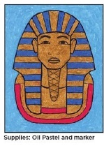  Death mask_step by step_guided drawing.doc  

