Create a necklace with Scarab beetle:

http://www.show.me.uk/editorial/1161-how-to-make-an-ancient-egyptian-scarab-necklace

The Ancient Egyptians were very fond of scarab beetles. You might have heard them referred to as dung beetles too. They thought that these beetles symbolised protection and re-birth. When they died, the Egyptians would often be given an amulet in the shape of a scarab beetle.
Show Me can show you how to make your own version of an amulet at home. This amulet would go brilliantly with an Ancient Egyptian costume - did you know that one of the oldest garments ever found belonged to an Egyptian?
For your amulet, you will need:
- Tin foil
- Paint brushes
- Red, blue and gold paint (if you haven't got gold, try yellow paint)
- Card (an old cereal packet will do)
- Macaroni pasta painted in red, blue and gold - save some gold macaroni for the necklace 'chain' (or you can cut up straws and cover them in tissue paper or coloured paper)
- A needle and thread for the chain of the necklaces
- Glue (PVA glue is best)
- Tissue paper or paper to cover the tin foil scarab and red jewel decoration on the necklace.
For the scarab necklace
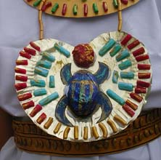
Make a scarab beetle by scrunching up tin foil into an egg shape and then flatten it enough so you can stick it to the necklace.
Make another circle out of tin foil for the red jewel decoration and flatten one side of it.
Draw the shape of the scarab beetle's body and legs on card as shown.
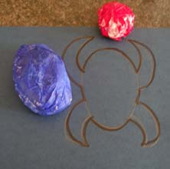
Cover the beetle shape in blue tissue paper using the glue. If you haven't got tissue paper, use newspaper and then paint it when it's dry. If you don't have these - draw a scarab beetle, colour it in and stick it to your necklace.
Do the same for the red jewel decoration.
When your painted macaroni is dry, glue it to the gold card in a pattern around the scarab beetle.
For the necklace 'chain'
Use a needle and thread to string up some of the gold macaroni. If you don't have these, try string instead and colour it in with a yellow felt tip pen.
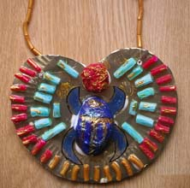
Find out more and see a real scarab Ancient Egyptian beetle decoration in Birmingham Museum and Art Gallery's online collection, BMAGiC.
If you find the Ancient Egyptians as fascinating as we do, why not check out our guide to museums with amazing Egyptian artefacts?
All images copyright Culture24 unless otherwise stated.

