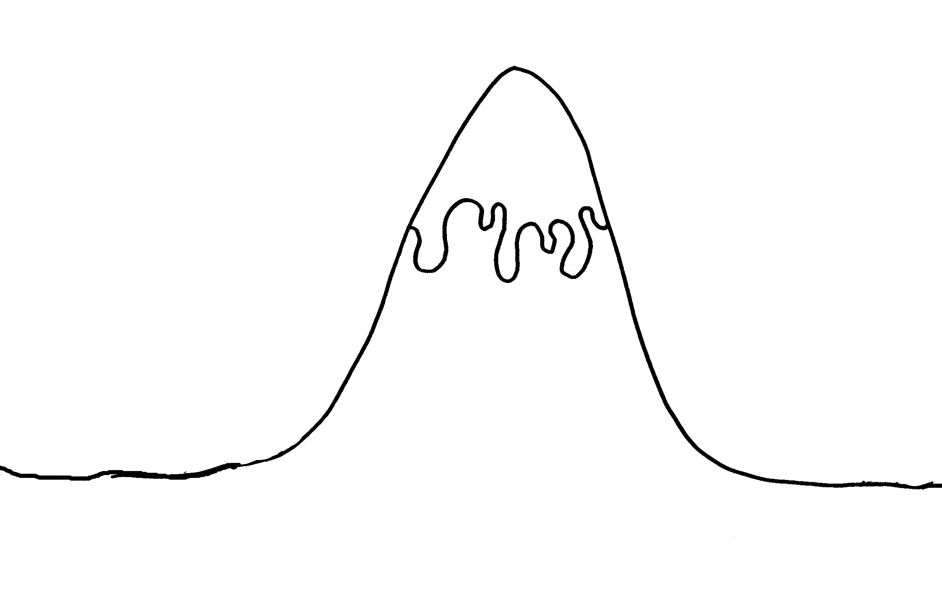
Problem fixed
L.O. To plan a story based on Tiddler
Introduction
Problem!
Ending
Build up
The Story Mountain
The Story Mountain

