Simple Salt Dough Recipe
It doesn’t matter what quantities you are using. It works on a principle of half, half and whole.
1 quantity of plain flour, ½ quantity table salt and ½ quantity of cold tap water.
For today’s batch I have used:
1 Cup of flour (8oz/225g)
½ Cup of Salt (4oz/112g)

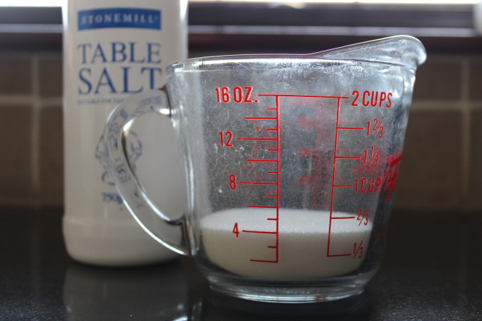

½ Cup of cold water (4floz/100ml)
Mix the flour and salt, together, in a bowl
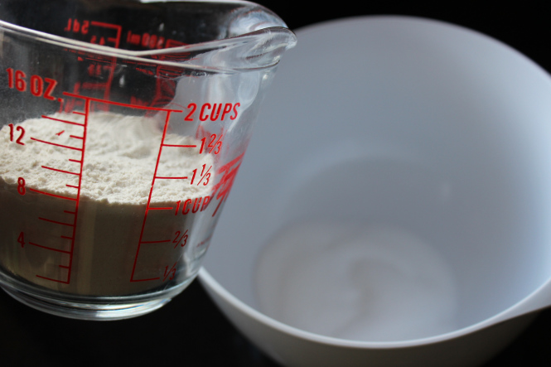
Gradually add the cold water and mix with a metal spoon. Do not add all at once.

When the mixture looks similar to the photo below, it’s ready. If there is a little water still in the jug, it’s fine! The mixture should not be soggy.
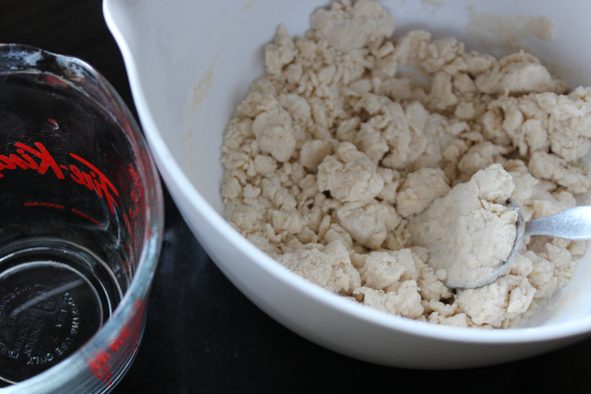

Time to get your hands in. Make into a ball. Beware! Salt can irritate some people’s hands.
Make sure after handling the dough you wash your hands thoroughly.

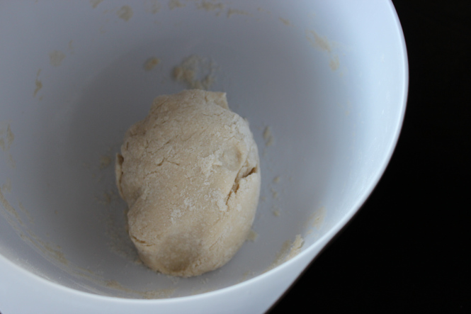

Knead the dough directly onto board or mat. If you’ve got your consistency right you shouldn’t need a dusting of flour. But if it starts to stick add some flour and work in.
Knead until smooth as you would biscuit dough.
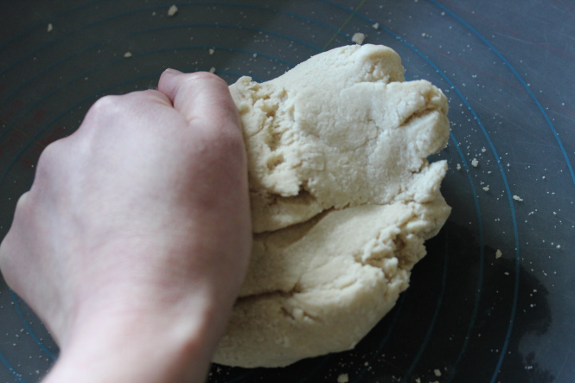

Make into a ball and press down to flatten slightly.
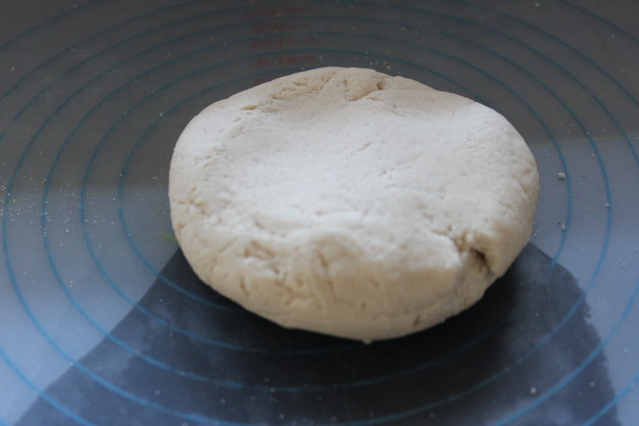

Roll out to the desired thickness and create landforms/topography as in Resource 3.


