Salt Dough Map Making
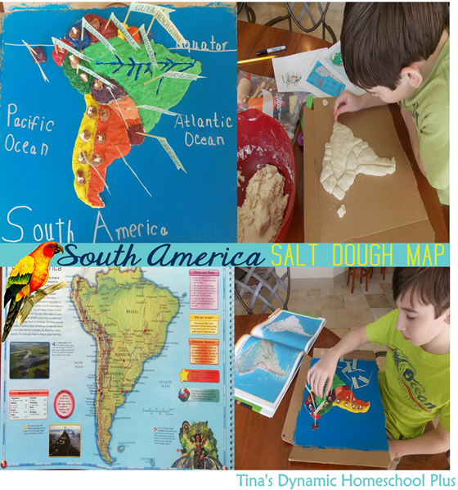
This map can be created for each of the continents to be covered where there is extensive rainforest.

Follow the Salt Dough instructions (other resource) for preparing the amount of salt dough for your class.
Suggested group size – 3/4 for each map.
Resources: Salt dough, base board, clay tools, paint, cocktail sticks, paper flags
Use either a Google Map image or a really good image of each continent from an atlas. It is important that it shows the topography/landforms. You may also like to have outline copies of the continents for the children to trace or copy as the basic shape (see photo 2).

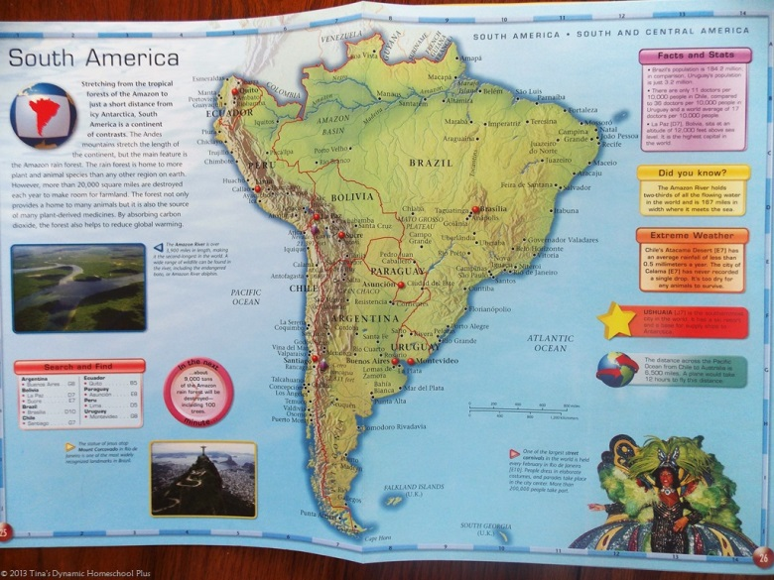

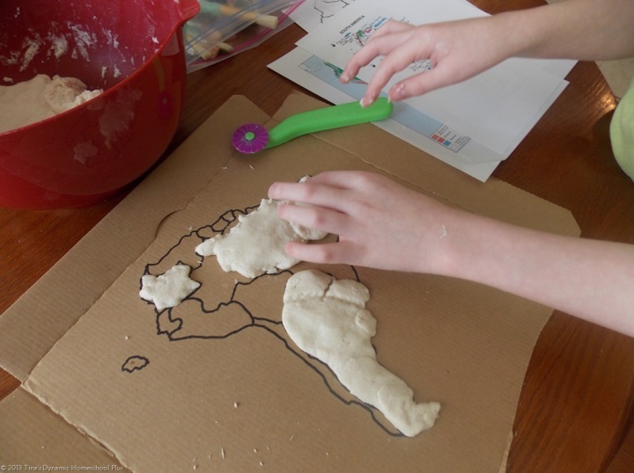

Use the salt dough to create the basic shape of the countries of the continent. This way it makes a clear divide between the countries for labelling.

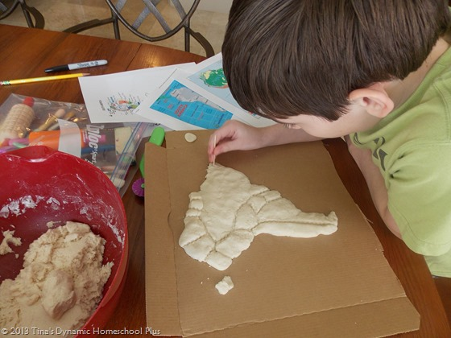

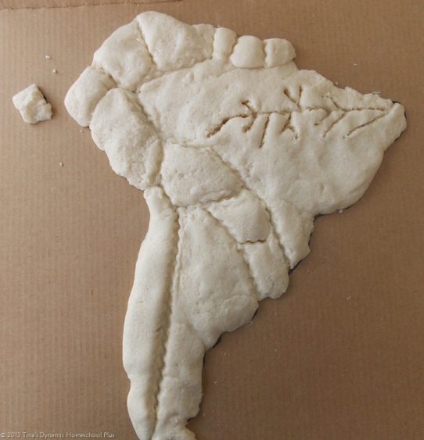

Using the atlas/Google map image carefully mark on key rivers, mountain ranges and rainforest regions with clay tools.
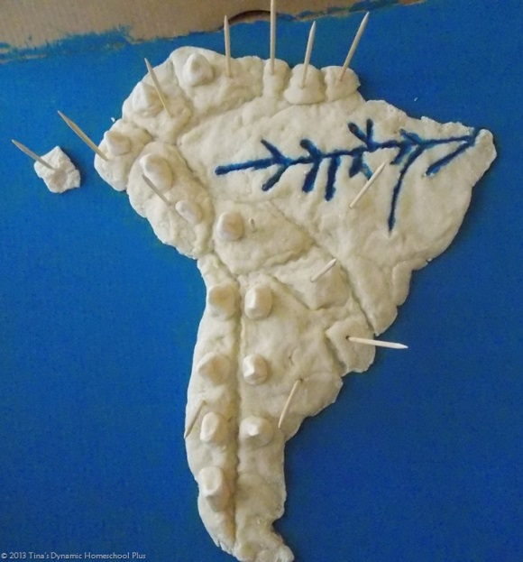
Once the modelling of the physical geography is complete add cocktail sticks for labelling, (so they are in place as your model dries out). Once the salt dough is dry (at least 24 hours), it can be painted and places, key landmarks and landforms can be labelled.


