Write on the CONTINENTS and the countries (with a capital letter for the name) onto the map where there are tropical rainforests marked. Label the Equator and the two tropics.

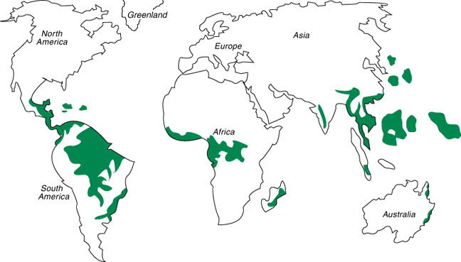

P
N
G

I

B
C

M

T

Write on the CONTINENTS in the boxes and the countries (with a capital letter for the name) onto the map where there are tropical rainforests marked. Draw on the Equator and label the two tropics.

Write on the CONTINENTS in the boxes and the countries (with a capital letter for the name) onto the map where there are tropical rainforests marked. Mark on and label the Equator and the two tropics.

