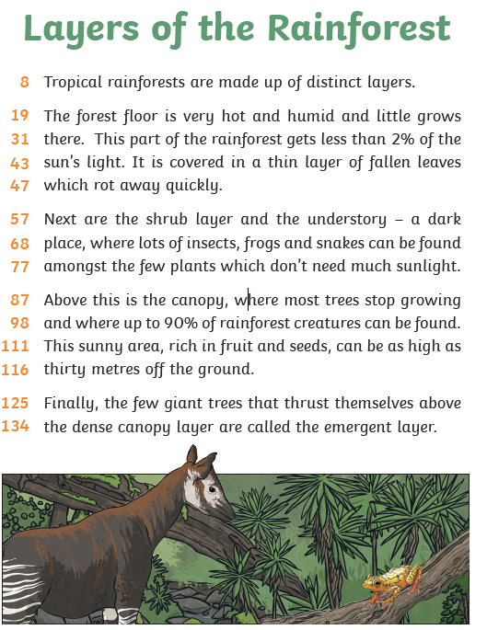
Find and underline the following words:
Distinct/ shrub/ creatures/ thrust/ dense
Line:

Layers of the rainforest:
Lines 8 – 47:
- Why do you think it is so dark on the forest floor?

- What happens to the fallen leaves on the forest floor?
Lines 57 – 77:
- What animals can be found in the shrub layer and understory?

- What sort of plants can survive in the understory?

Lines 87 – 116:
- What is the name of the layer where 90% of the animals can be found?

- How high is this layer?

- Why do you think so many animals like this layer?

Lines 125 – 134:
- What layer do the few giant trees form which grow taller than the canopy?

