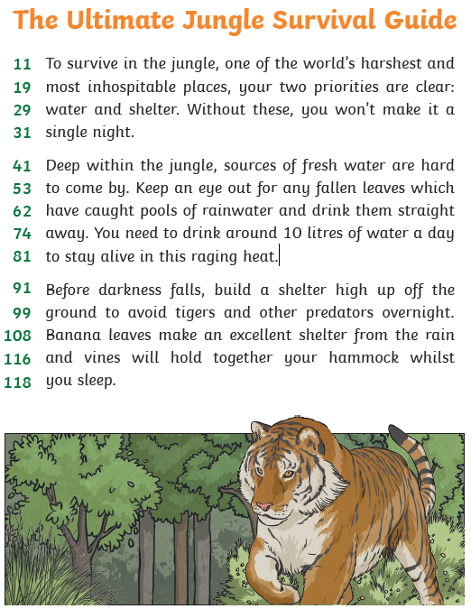
The Ultimate Jungle Survival Guide:
Lines 11 - 19
- What is the only way to survive in the jungle?

- What does ‘inhospitable place’ mean?

- Which sentence shows that the jungle is a very dangerous place?
Lines 41 – 81:
- Where can you find water?

- Why do you need to drink as much as 10 litres of water?

Lines 91 – 118:
- Where do you need to build your shelter? Why?

- What could you use to build you shelter?

- What is a hammock? Could you draw one?

Find and underline the following words:
harshest/ priorities/ raging/ predators/ vines
Line:

