Home Learning for EYFS
Reading  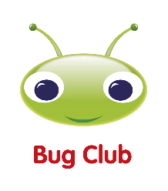  (10 minutes reading every day) | 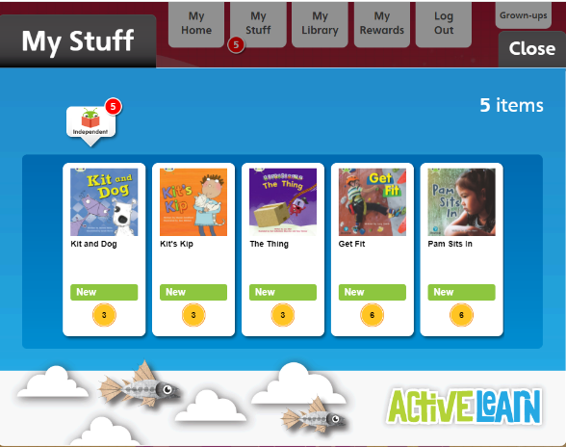  Read books allocated in your Bug Club account  https://login.pearson.com/  Remember to click on the bugs in the book to do the activities!
Drawing  Club  (1 drawing and writing every day) | 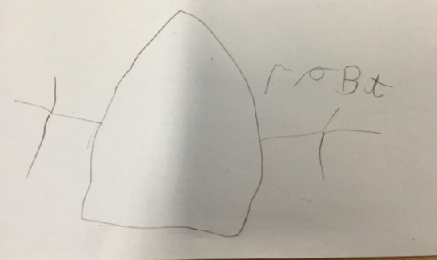  Choose one character or setting from one of the books you read in Bug Club. Draw it and try to add as many details as you can. Also, challenge yourselves by trying to write some labels using the Sound mat to support you.
Maths  (1 session per day) | https://whiterosemaths.com/resources?year=early-years  - Click Spring Term/ Alive in 5!  - Click on the Video symbol to watch the lesson  - Click on the paper symbol for an activity to be printed  Week 10th – 14th  (Session 1 – 5)  Week 17th – 21st January  Sessions 6 to 10  Week 24th – 28th January  Sessions 11 - 15  

