Name: ____________________
Miss Townley’s Class Maths Homework
Week given 17.01.2022. These are some of the things we will be looking at in our Maths set this week. Here are some questions for you to practise at home and return next Monday (24.01.2022).

RUC  Read the question  Understand the questions and Underline key parts  Choose the operation | SAC  Solve the problem  Answer the question  Check your answer
Miss Townley has 637 pencils and 289 rubbers. How many more pencils than rubbers does she have?
Hannah went to the shops and bought a keyring, rubber and a ruler. How much did she spend altogether?
Keyring | £3.99
Rubber | £1.20
Ruler | £1.99


Sarah has £30 for her trip to London. She spends £9.67 on tickets and £13.37 on some shopping. How much does Sarah have left?

Mr Klein wants to book a holiday to the Caribbean. He has a budget of £400. His flight will cost £240. His accommodation will cost £75. How much will be have left to spend?
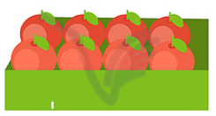
Harry has 6 boxes of 8 apples.
How many apples does Harry have?


Tilly has 28 cupcakes.
They are in boxes of 4.
How many boxes does Tilly have?

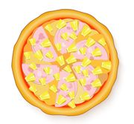
Sam makes a Pizza with ham and pineapple toppings.
He uses 3 ham slices for every 5 pineapples. The finished pizza has 15 pineapple pieces. How much ham is there?



