Name: ____________________
Mrs Stagg’s Class Maths Homework
Week given 17.01.2022. These are some of the things we will be looking at in our Maths set this week. Here are some questions for you to practise at home and return next Monday (24.01.2022).

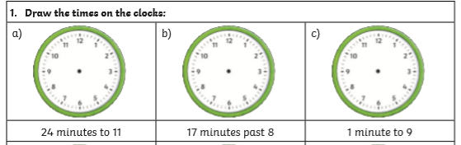
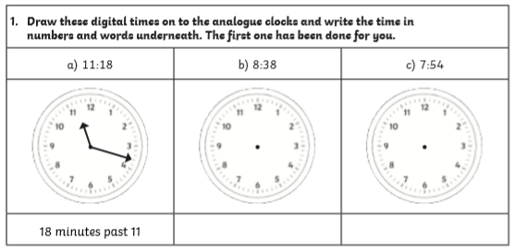
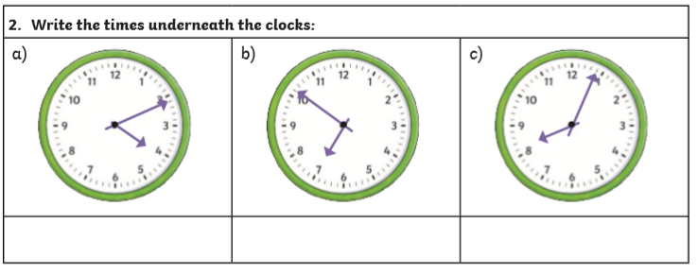
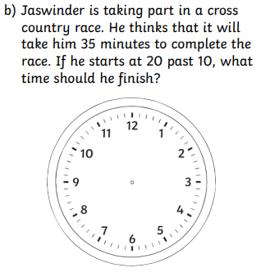
Draw your answer on the analogue clock and write the digital time underneath



