LAYERS OF A RAINFOREST
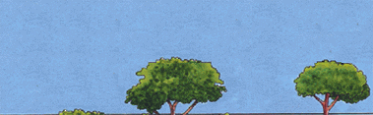 | EMERGENT LAYER  The tallest trees are the emergents, towering as much as 200 feet above the forest floor with trunks that measure up to 16 feet around. Most of these trees are broad-leaved, hardwood evergreens. Sunlight is plentiful up here. Animals found are eagles, monkeys, bats and butterflies.
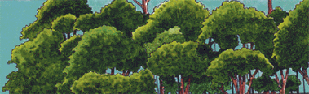 | CANOPY LAYER  This is the primary layer of the forest and forms a roof over the two remaining layers. Most canopy trees have smooth, oval leaves that come to a point. It's a maze of leaves and branches. Many animals live in this area since food is abundant. Those animals include: snakes, toucans and treefrogs.
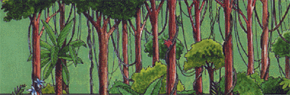 | UNDERSTORY LAYER  Little sunshine reaches this area so the plants have to grow larger leaves to reach the sunlight. The plants in this area seldom grow to 12 feet. Many animals live here including jaguars, red-eyed tree frogs and leopards. There is a large concentration of insects here.
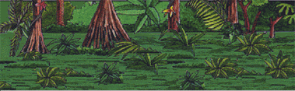 | FOREST FLOOR  It's very dark down here. Almost no plants grow in this area, as a result. Since hardly any sun reaches the forest floor things begin to decay quickly. A leaf that might take one year to decompose in a regular climate will disappear in 6 weeks. Giant anteaters live in this layer.

