Home Learning for EYFS
Reading  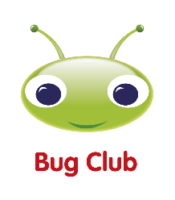  (10 minutes reading every day) | 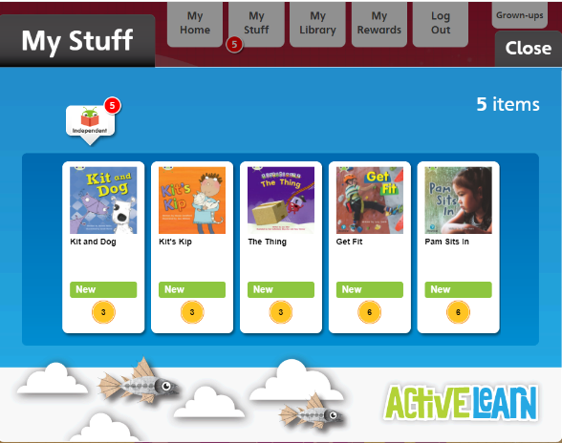  Read books allocated in your Bug Club account  https://login.pearson.com/  Remember to click on the bugs in the book to do the activities!
Drawing  Club  (1 drawing and writing every day) | Choose one character or setting from one of the books you read in Bug Club. Draw it and try to add as many details as you can. Also, challenge yourselves by trying to write some labels using the Sound mat to support you.  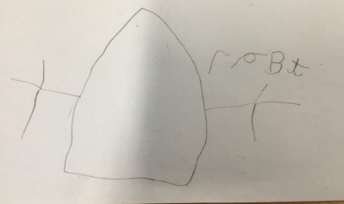
Maths  (1 session per day) | https://whiterosemaths.com/resources?year=early-years  - Click Spring Term/ Growing 6, 7 8  - Click on the Video symbol to watch the lesson  - Click on the paper symbol for an activity to be printed  Week 31st January – 4th February 2022  Session 1 – 5  Week 7th – 11th February 2022  Sessions 6 to 10  Week 14th – 18th February 2022  Sessions 11 - 15  

