Miss Townley’s Class Maths Homework
Week given 28.02.2022 – These are some of the things we will be looking at in our Maths set this week. Here are some questions for you to practise at home and return next Monday (07.03.2022).

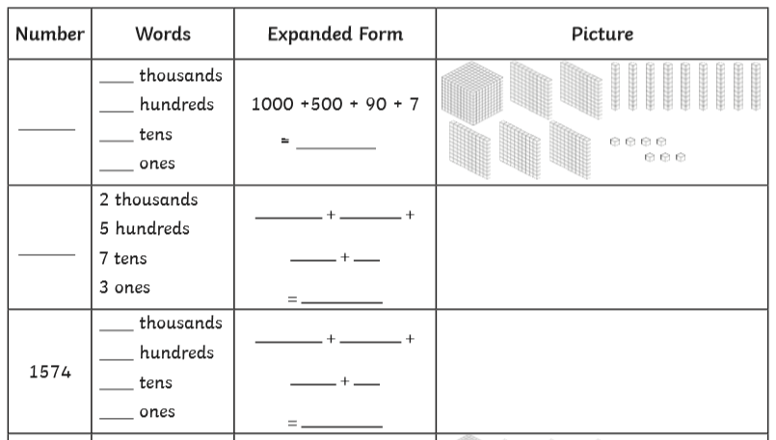

- What does the underlined digit stand for?
1,275 = _________
2,412 = _________
3,023 = ________

4. Arrange the digits to make a number that meets the criteria:
3. Use the digits below to make a three-digit number with:
5 4 2

- 5 hundreds ____________

- 5 tens ____________

- 5 ones ____________

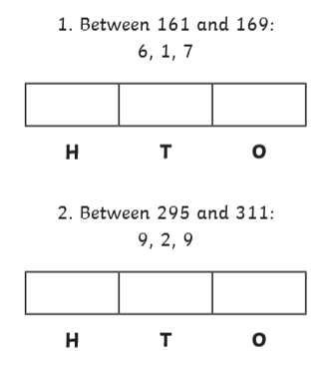

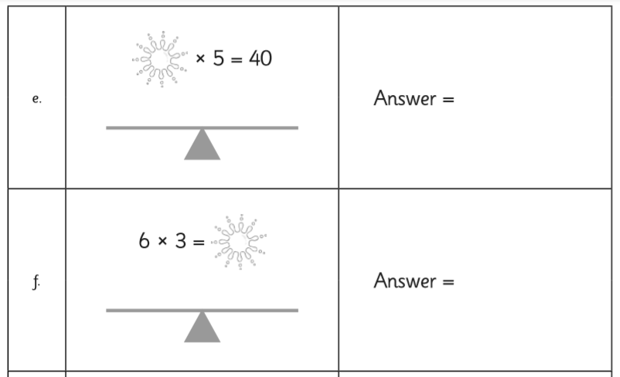
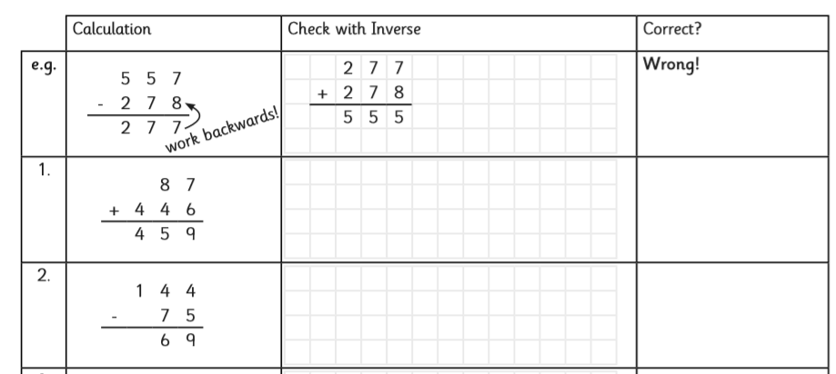
8. Use the digits and symbols to write two correct calculations with different answers.

5 45 9 ÷ x =

 | 7 |  | 5
- | 1 | 2
 | 6 | 1 | 2

 | 4 | 4 | 8
+ | 2 |  | 7
 | 7 | 3 | 5

6. Fill in the missing digits:
 | 3 | 1
+ | 1 |  | 2
 | 4 | 7 | 5

