Mrs Stagg’s Class Maths Homework
Week given 28.02.2022 – These are some of the things we will be looking at in our Maths set this week. Here are some questions for you to practise at home and return next Monday (07.03.2022).

- What does the underlined digit stand for?
12,375 = _________
25,412 = _________
379,023 = ________

2. Use the digits below to make a four-digit number with:
5 4 2 6

- 4 thousands ____________

- 5 tens ____________

- 6 hundreds ____________
3. Arrange the digits to make a number that meets the criteria:

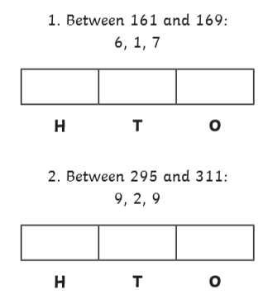

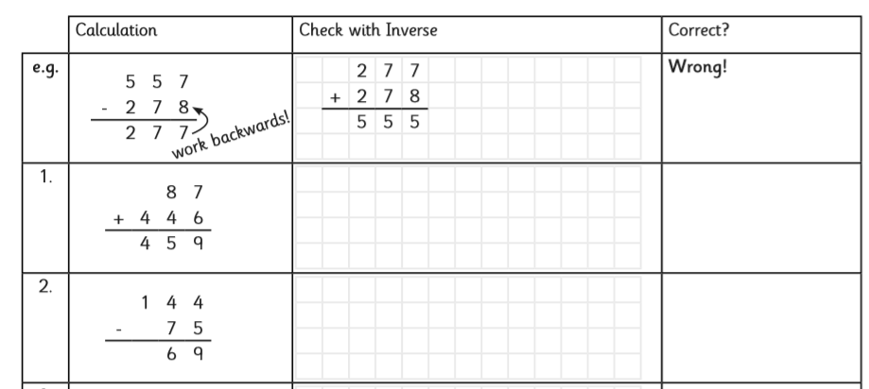
4.
5. Fill in the missing digits:
 | 3 | 4
+ | 1 |  | 3
 | 4 | 6 | 7

 |  | 7 |  | 7
- |  | 1 | 2
 |  | 6 | 3 | 2

 | 4 | 5 | 8
+ | 2 |  | 7
 | 6 | 6 | 5

6. Answer these calculations by finding the missing numbers:
4 x 12 =
x 6 = 36
9 x 8 =
x 7 = 49
3 x = 27

7.
Laura has these even digits on cards:


