WB 28.03.22 L.O - To know some of the events of Holy Week and where they fit into the life of Jesus.
Palm Sunday | 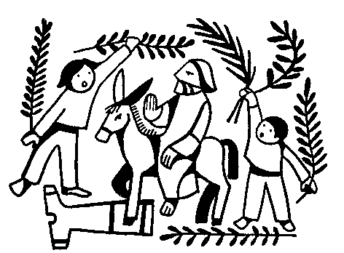
Monday | 
Tuesday & Wednesday | 
Maundy Thursday | 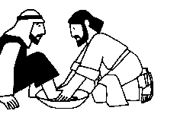 | 
Good Friday | 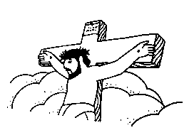

L.O. - To know some of the events of Palm Sunday.



