God Matters: Supplementary Guidance

Year One: Holy Week
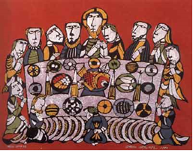

Jesus gave himself freely to save us. At the Last Supper he makes present his life, death and resurrection.

Rationale
This unit introduces more detail about the events of Holy Week. It should enable pupils to explore all the things that Jesus did for us. It highlights the importance of the Last Supper and introduces the Stations of the Cross as a prayer. Focus should be on discussion, dialogue and sequencing the events. Connection between these events and the prayer life of the Church should also be made.

Theology
The entire life of Jesus was a free offering to the Father to carry out His plan to save us.

At the Last Supper with his apostles on the night before he died, he both symbolised and made really present his self-offering

REVISED PROFILE OF THE YEAR ONE CHILD IN RE
AT1: KNOWLEDGE AND UNDERSTANDING (‘learning about’)
Developing Knowledge and Understanding
- Throughout key stage one, the children experience a rich diet of Bible stories, from both the Old and New Testaments. They hear about and can recognise key figures in the history of the People of God and can describe a key feature of their life or work. Children begin to develop a religious time line, for example, before Jesus, during the time of Jesus, after Jesus returned to Heaven.
- In Year One, they hear the stories being read to them or through video, and are given opportunities to talk about them, reflect on them and act them out. The pupils are given opportunities to show they recognise the stories by sequencing or recording a few key events and/or characters in the narrative through word and/or illustration, drama, hot seating, freeze frames. More able will be able to retell, in any form, a narrative that corresponds to the scripture source used.
- Thinking skills activities are used or adapted to provide a scaffold for pupils to record their thoughts in a few words or sentences or illustrations, depending on their ability.
- Pupils now have an individual book for RE.
- Children are introduced to common religious signs and symbols and are provided with opportunities to talk about how people pray, including how we worship together in school, home and in church. Introduced to some of the special occasions we come together to worship, e.g. mass, baptism and weddings. This is supported by visits to church, and/or visitors, e.g. priest, deacon.
- The meaning behind some of the more common prayers, e.g. Sign of the Cross and Our Father, is explored. Pupils are more confident in joining in common, and any specific school, responses to prayer.
- Children are able to write their own simple prayer following a structure/framework/example given to them.
- They are developing an awareness of the liturgical year/colours and key festivals. As they go through the year, they are introduced to different types of prayer to reflect the season.
- Children are told about a range of religious beliefs and they are helped to record the key aspects.
- At a simple level, examples are shared of how people’s faith mean they act in a particular way. Examples are used that are wider than praying together and going to church – examples of living out of Catholic social teaching are used without using this terminology. The actions of everyday people, e.g. people in our family, school, parish, neighbourhood are used as well as people who are known more widely. Children begin to see how actions come from people’s religious beliefs, and they begin to show their understanding of how they are linked.
- Introduced to some of the different roles in the church, e.g. parish priest, deacon, religious sisters (if local to the school), the Pope.
- Where appropriate, this work is also linked to the school’s mission statement.
Religious and Specialist Vocabulary
- Begin to build up a religious and specialist vocabulary through their study of the various God Matters units.
AT2: ENGAGEMENT AND RESPONSE (‘learning from’)
Meaning and Purpose
Say what they wonder about and begin to ask wondering questions about all the areas of study. Teachers share some questions that are difficult to answer.
Use of focused questions linked to unit being studied.
- Regular use of talk partners.
- Response to questions can be expressed through photos, artwork and drama.
Beliefs and Values
Talk about their own feelings, experiences and the things that matter to them and begin to ask and respond to questions about their own and others’ feelings, experiences and things that matter to them.
- Plan opportunities for them to share their opinions and consider opinions of others, for example, favourite part of a parable, scripture story – why?
- Begin to look at different perspectives within stories/events.
- Reflecting on a Bible story – what will you do differently now?
- Following discussion, writing/recording what they liked/disliked about the story.
- Debates – record key discussion points, thoughts in class Big Book.
- Explore multi-faith resources.
- Discuss others’ beliefs – identifying similarities between other faiths and the Catholic faith.

YEAR ONE: HOLY WEEK

Highlights the importance of the Last Supper and introduces the Stations of the Cross as a prayer.
Key scripture and background | Key vocabulary
Within God Matters:  Luke 19:28-38 – Palm Sunday  Matthew 26:20-29  Mark 14: 17-25  Luke 22:14-23 Last Supper  John 13:1-15 Washing of the Feet  Resources  www.loyolapress.com | Bread – Body – At the Last Supper, Jesus said, ‘This is my body/this is my blood’. At the Eucharist, the bread and wine are changed to his body and blood to re-enact the Last Supper.  Last Supper – The Passover meal Jesus shared with his disciples when he established the Eucharist.  Palm Sunday – Jesus’ triumphal entry into Jerusalem, so called because cheering crowds laid palm leaves for him to walk on.  Washing of the Feet – Jesus’ action to perform this most menial task, declaring himself to be a servant and committing his followers to also serve.  Wine – Blood – see Bread – Body above
HOLY WEEK - KEY QUESTIONS FOR YEAR ONE
‘What can I find out about what happened to Jesus during Holy Week?’

Why were the crowds so pleased to see Jesus?
What does ‘Hosanna’ mean?
Why is the meal Jesus shared with his disciples called the Last Supper?
Where and when did he share the meal?
How different would the Last Supper be from the first supper the disciples shared together? (Potential for greater depth)
What did Jesus say when he gave the bread and wine to his disciples?
Why do you think he said these words? (Potential for greater depth)
Where do you hear these words being spoken? What do they make you think?
What would the disciples be thinking and feeling as Jesus said these words to them? (Potential for greater depth)
Why did Jesus was his disciples’ feet?
What is the message for us?

THE FOLLOWING ACTIVITIES SHOULD BE CONSIDERED ALONGSIDE THE ORIGINAL GOD MATTERS PLANNING
OPPORTUNITIES TO DEMONSTRATE EXPECTED STANDARDS IN RE FOR AGES 5 - 7
Developing Knowledge and Understanding  - Recognise religious stories  - Retell, in any form, a narrative that corresponds to the scripture source used  - Recognise religious beliefs  - Recognise that people act in a particular way because of their beliefs  - Describe some of the actions and choices of believers that arise because of their belief  - Recognise key figures in the history of the People of God  - Describe the life and work of some key figures in the history of the People of God  - Recognise key people in the local, national and universal Church  - Describe different roles of some people in the local, national and universal Church  - Recognise religious signs and symbols used in worship, including the celebration of the Sacraments.  - Describe some religious symbols and the steps involved in religious actions and worship, including the celebration of the Sacraments.  Religious and specialist vocabulary  - Use religious words and phrases. | Links to unit  Events of Holy Week  Palm Sunday  Last Supper  Eucharist  Attending Mass  Eucharist/attending Mass  Jesus and Disciples  Last Supper  Pope, priest  Pope  ‘Welcomers’ at Mass  Celebration of the Eucharist  Eucharist  See key vocabulary | - What do they remember about Holy Week? Together draw up a time map of the week.  - Share the story of the week using an appropriate version/video, or alternative e.g. Resurrection Eggs.  - Which part do they like most? Which do they think is the most important? Why?  - Children to choose a symbol for each major event and write a sentence summarising each one.  - Explain that they are going to start with looking at what happened on Palm Sunday.  - Using props, costumes etc. help the children re-enact the story of Palm Sunday.  - Why do they think all the crowds were there to see Jesus? What would they shout if they saw Jesus coming?  - How can we welcome others?  - If possible, obtain palms from Church and help them make a palm  - cross. Why do we make crosses from palms?  - On an outline of a palm leaf, children to write as one of the crowd on Palm Sunday – what did they see, feel, shout out etc.  - Move onto the Last Supper. Act out as a class using bread and juice. Include the washing of the disciples’ feet. Take photos for class book  - Class discussion on what they think was happening at the Last Supper. Help them draw links with the celebration of the Eucharist.  - Children to complete a recount/retell of the Last Supper. Finish with them writing about which part they think is the most important and why.
Meaning and Purpose  - Say what they wonder about  - Ask wondering questions about all of the areas of study and recognize that some questions are difficult to answer | Will come from discussions on above
Beliefs and Values  - Talk about their own feelings, experiences and the things that matter to them  - Ask and respond to questions about their own and others’ feelings, experiences and things that matter to them | Opportunities will come from discussions on above
GREATER DEPTH OPPORTUNITIES
- Children to retell the story of Palm Sunday from the viewpoint of one of the Jewish priests.
- Create their own story sack for the Last Supper and use it to retell the story to children in Early Years or Nursery.
- (Check out - How do we ensure those lacking literacy skills are supported in RE so we can accurately assess their RE skills and knowledge?)

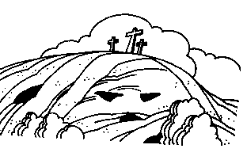
The Events of Holy Week
Holy Week is the last week of Lent, when we follow Jesus from Palm Sunday, the Sunday of the Passion, to his death on Good Friday in preparation for his rising from the dead on Easter Sunday.
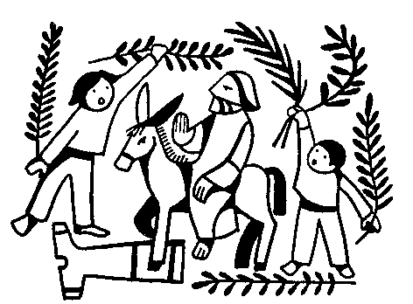
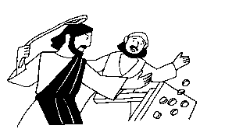
Palm Sunday: Accompanied by his disciples, Jesus rode into Jerusalem on a colt, while crowds of people covered the streets ahead of him with their cloaks and with palm branches.

Monday: Jesus chased the money-changers out of the Temple.
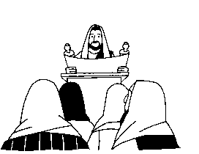

Tuesday and Wednesday: Jesus preached and taught in Jerusalem.

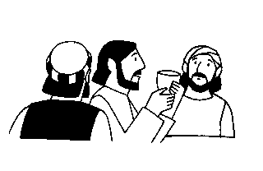
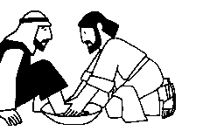
Thursday: After washing the feet of the disciples, Jesus celebrated the Feast of the Passover, instituting the Sacrament of Holy Communion.

After the supper, Jesus and his disciples went to Gethsemane to pray, where he was arrested by the Temple guard and taken to an illegal night session of the Jewish court, the Sanhedrin.
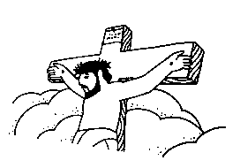
Good Friday: Jesus was taken into Roman courts, before Pontius Pilate and Herod Antipas, who sent him back to the Jewish court. Roman soldiers took him to Golgotha, the place of the skull, where he was crucified.
Saturday: Jesus rested in the tomb while his disciples observed the Sabbath.

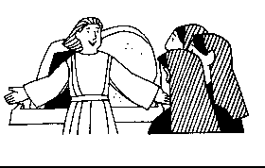
Easter Sunday: An angel met Mary Magdalene and "the other Mary" (perhaps Mary, the mother of James and John) at the tomb to tell them that Jesus was risen from the dead.

