Home Learning for EYFS Spring 2 (28th March – 7th April 2022)
Reading  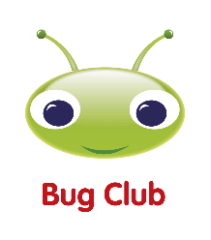  (10 minutes reading every day) | 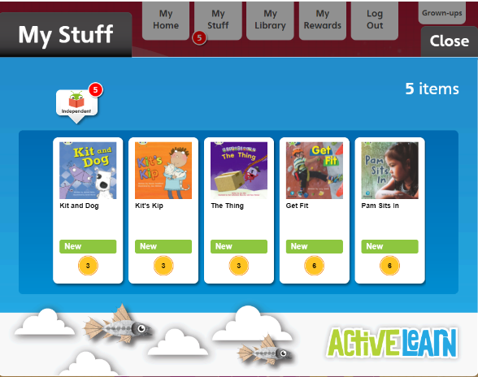  Read books allocated in your Bug Club account  https://login.pearson.com/  Remember to click on the bugs in the book to do the activities!
Drawing  Club  (1 drawing and writing every day) | 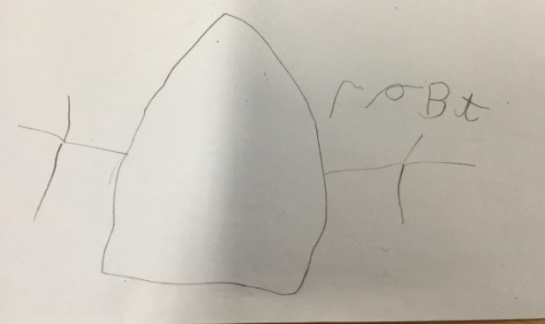  Choose one character or setting from one of the books you read in Bug Club. Draw it and try to add as many details as you can. Also, challenge yourselves by trying to write some labels using the Sound mat to support you.
Maths  (1 session per day) | https://whiterosemaths.com/resources?year=early-years  - Click Spring Term/ Building 9/ 10  - Click on the Video symbol to watch the lesson  - Click on the paper symbol for an activity to be printed  Week 28th March – 1st April  (Session 10 –15)  Week 4th – 7th April  White Rose Maths app: 1 Minute  Subitising & Addition games



