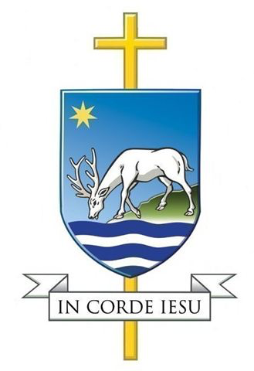

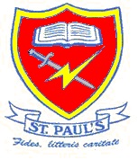

RE NEWSLETTER for PARENTS ~ AUTUMN TERM 2023

This term our three main topics in Religious Education are

Creation, Catholic Social Teaching and Advent

Special days

this term

Our Lady’s birthday

8th September

St Matthew

21st September

St Jude

28th October

All Saints Day

1st November

Christ the King

26thNovember

1st Sunday of Advent 3rd December

St Andrew

30th November

Immaculate Conception

8th December

St John

27th December

Mission
In the first week of the new year
we spend time looking at our school mission statement and what it means to our community.

Mary
We celebrate Mary’s birthday on 8th September and spend a lesson learning more about her.

Creation
Learning about God through Old Testament stories, praising God for his Gifts and responding to his call.
You can help by sharing Old Testament stories with your children and discussing with older children what the stories tell us about God and the people featured


Harvest and CAFOD
We have our annual harvest festival and provide food for our local community. We learn what CAFOD does to help people in need around the world.

Catholic Social Teaching

We look at the different strands of Catholic Social Teaching and the Pope’s responses in Laudato Si and Fratelli Tutti.

You can help by talking to the children about how we can make the world a better, fair place for everyone, sharing ideas about how everyone can make a small difference.

Advent
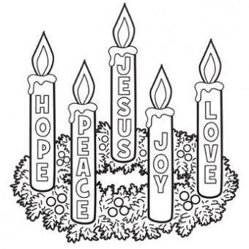

Learning the story of the Nativity, preparing for Christmas and recognising Christ in the world. Understanding the roles of some of the people in the stories surrounding Jesus’ birth.
You can help by involving your children in your pre-Christmas preparations and looking at the symbols and traditions associated with this time.

OTHER FAITHS
In each unit we also look at a different World Religion and identify how they have parallels with and differences from our own faith.

The Children study each topic at their own level with progression through the school. This is an overview of what will be covered in each year group.
Creation
Reception | Children will be introduced to the Bible and making the Sign of the Cross. They will hear the story of Creation, go for a walk in our grounds and talk about all the things God made. They will visit our parish church.
Years 1 and 2 | The children will learn to sequence the story of Creation will particular emphasis on caring for our world. They will express the Creation story in art, drama or dance. Children will think about how they can praise God for all he has given us.
Years 3 and 4 | Children will learn about the Sacrament of Baptism and may share stories and pictures of their own baptisms. They will learn about the Baptism of the Jesus and the stories about the call of the first disciples.
Years 5 and 6 | The children will study the two versions of the Creation with a particular emphasis stewardship. They will explore the letters of St Paul and the Beatitudes.

Catholic Social Teaching
Reception | The children will talk about who loves them and who they love and think about ways we can show our love for others. They will listen to the parables of the Good Samaritan and the Mustard Seed
Years 1 and 2 | We will build on work in the Creation unit to explain how we are given the important role of being stewards of God’s Creation. The children will explore links between Catholic Social Teaching particularly the Christian duty to reach out to those in need, and parables told by Jesus.
Years 3 and 4 | Children will explore links between Catholic Social Teaching and the Gospels. We will particularly focus on the Christian duty to value everyone as a child of God and show them dignity and respect.
Years 5 and 6 | This topic explores how we can all make a difference, however small, to improve our common home. Children will look at the links between the Gospels and Catholic Social Teaching particularly the Christian duty to lead by example and reach out to those in need.

Advent
Reception | Children will learn about the Advent wreath and have the opportunity to help make a class wreath. They will hear the story of the Annunciation to begin the story of the Nativity. There will be plenty of singing Christmas carols and songs.
Years 1 and 2 | The children will think about Advent as a time of preparation for Christmas, a time to look back and to look forward. They will learn about the journey to Bethlehem and how Mary and Joseph prepared for Jesus’ birth.
Years 3 and 4 | Children will learn the story of the Annunciation in more detail, how Mary said ‘yes’ to the Angel. They will learn the story of the Visitation and about the Jesse Tree as background to the forthcoming birth of Jesus.
Years 5 and 6 | The children will learn about the two parts of Advent: Preparing for Jesus’ birth and his Second Coming. They will study the roles of John the Baptist and the Old Testament prophets in preparing the way for Jesus.

