WK | Skills and LO | Lesson/ Art work
Creating a continent e.g. Brazil from Salt dough | Form/ Sculpture – 3D work: clay, dough, wire, paper, mod roc  D&T: To generate, develop, model and communicate their ideas through discussion, annotated sketches and pattern pieces; To select from and use a wider range of tools and equipment to perform practical tasks.  To use salt dough to create a continent map showing topography, rainforests and major rivers and cities. | 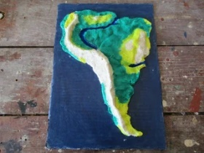  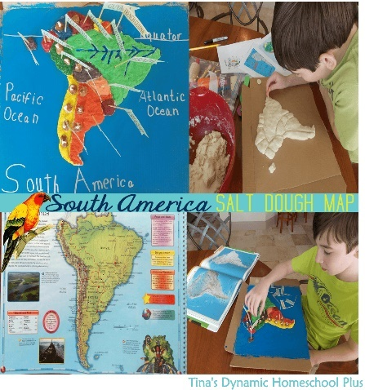
Create a terrarium  Each group to create a humid environment for different seeds (e.g. herbs) to grow and compete for light with each other | Form/ Sculpture – 3D work: clay, dough, wire, paper, mod roc  Create a small scale rainforest environment and watch a ‘rainforest’ develop. | 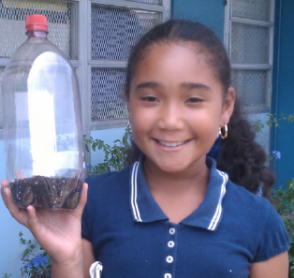
Creating a collage of the different layers of the rainforest in groups of 4.  Each child to work on a different layer.  Provide children with facts (what plants and animals to find) for each layer. | Form/ Sculpture – 3D work: clay, dough, wire, paper, mod roc  D&T: Select from and use materials, including construction materials and textiles, according to their functional properties and aesthetic qualities.  To make group dioramas (or displays) of understory layer and forest floor of the rainforest e.g. in shoe boxes or on sugar paper, including the creatures found in these layers. | 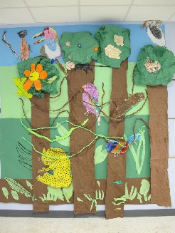  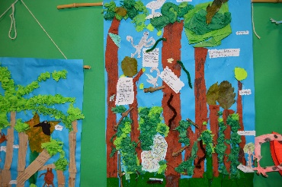
Modroc animals | Form/ Sculpture – 3D work: clay, dough, wire, paper, mod roc  Art: To improve their mastery of art and design techniques, including drawing, painting and sculpture with a range of materials.  (Create a structure using newspaper and masking tape. Then cover with Modroc.) | 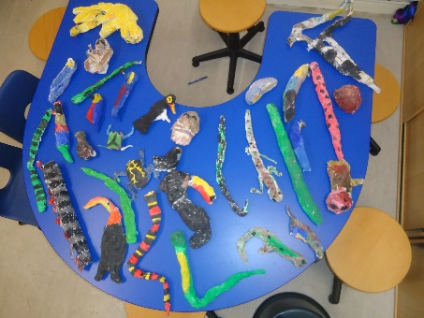
Draw Tribal people | Drawing – pencil, charcoal, ink, pastel  Art: Develop art techniques, including their control and their use of materials.  To carefully observe the faces of the Kayapo tribe and create their own portraits of the people for a wall display. | 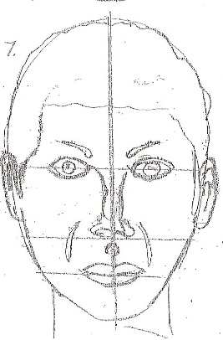  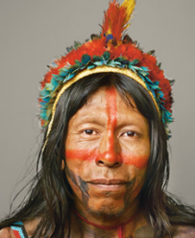
Design patterns | Drawing – pencil, charcoal, ink, pastel  Art: To improve their mastery of art and design techniques, including drawing, painting and sculpture with a range of materials.  To explore the similarities and differences between our own culture and the Kayapo tribe.  To use the design of the Kayapo Tribe to create own works of art. | 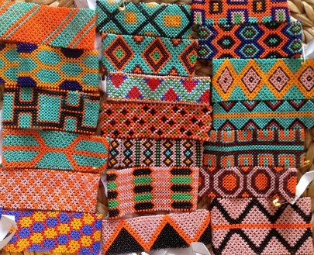

How to draw a face for kids:
https://www.youtube.com/watch?v=s3TikcVkFow
https://www.youtube.com/watch?v=uXlO6ocidiY

