56, 58, ____, 62, 64, __, 68, _____, _____  Add the missing numbers.  What is the rule for this sequence?  Count in: | 110, 210, 310, ____, 510, 610, _____  Write the sequence into your book followed by the next two numbers.  What is the rule for this sequence?
34, 36, _____, 40, 42, ____, 46, ____  Write the sequence into your book followed by the next two numbers.  What is the rule for this sequence? | 123, 223, 323, 423, 523, ____, ___  Write the sequence into your book followed by the next two numbers.  What is the rule for this sequence?

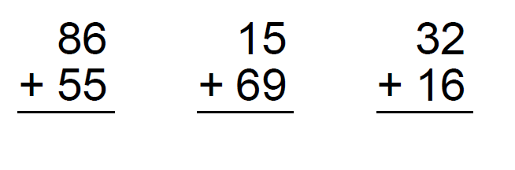
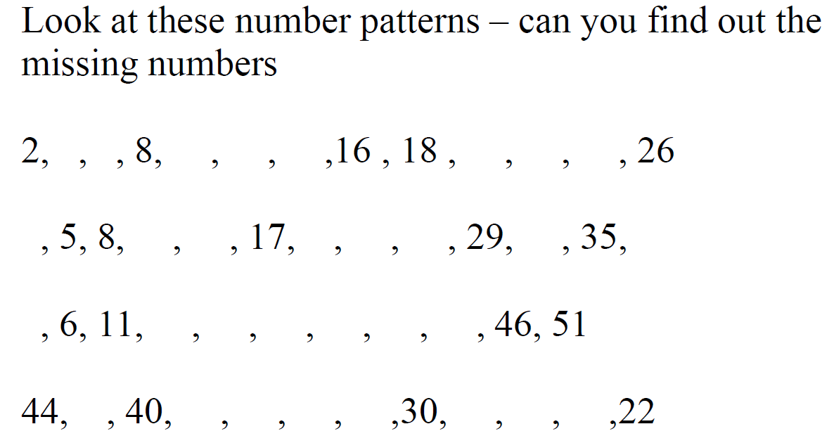
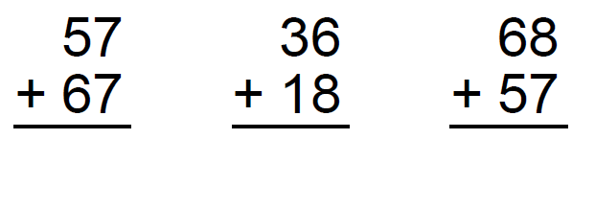

Challenge:
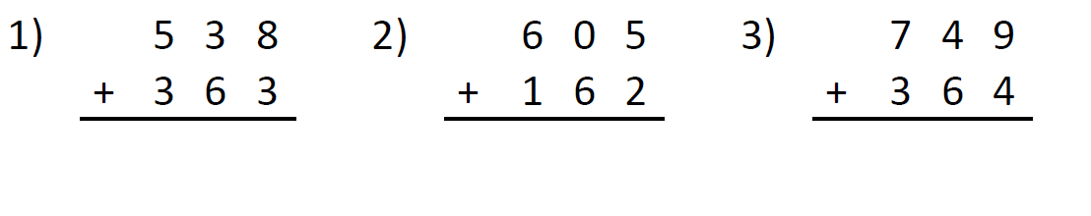

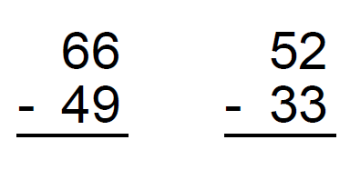
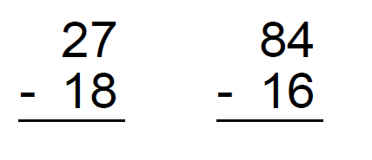

Challenge:

