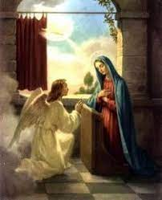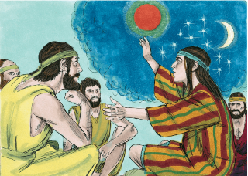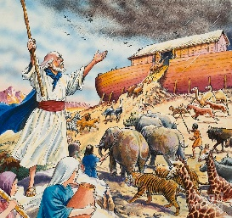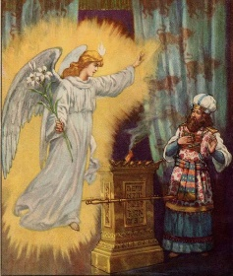

**RE W.B 10.01.2022**

**Discussion - Hearing or Listening?**

How do others let us know what they want us to do? Think of ways others can let them know what they want us to do – parents, teachers, friends etc. How do you think God lets his people know what he wants them to do? Can you think of any examples from the Bible where God revealed his plans/message to others?

**Activity –** Look at examples from the bible where God speaks to people

e.g. Noah, Jonah, Joseph (in dreams) Zechariah, Mary (an angel) perhaps they might add when Mary appeared eg to Bernadette at the grotto. On the worksheet below, write/draw about message(s)from God – who received the message/how/what was it/what did they do?

LISTEN